Nexelus Database Server

esm_logo.jpg

Nexelus USA  
New York, NEW YORK (NY)  
646-558-1950 ext.128

**1/27/2022**

# Document Information

The following table shows the details for document creation, review, approval, and effective date.

| **Category** | **Information** |
| --- | --- |
| Work Product: | Nexelus Database Server |
| Project Name: | Server Setup |
| Function Name: | Database Server Setup |
| Version: | 0.1 |
| Status: | Draft |
| Author(s): | Tauseef Shahzad |
| Reviewer(s): | Asim Jameel |
| Approver(s): | Imran Rahman |
| Control Status: | CONTROLLED, PROTECTED |
| Disclaimer: | This document contains confidential information. Do not distribute this document without prior approval from Nexelus. |

# Revision History

The following table is used for revision details of this document.

| **Author(s)** | **Date** | **Version** | **Description of Change** |
| --- | --- | --- | --- |
| Anees Ur Rahman | Jan 2, 2022 | 0.1 | Initial Draft |

# Table of Contents

Contents

[Document Information ii](#_Toc94172659)

[Revision History iii](#_Toc94172660)

[Table of Contents i](#_Toc94172661)

[Scope 1](#_Toc94172662)

[Windows Server Configurations 2](#_Toc94172663)

[Windows Roles and Features 3](#_Toc94172664)

[Additional Software 5](#_Toc94172665)

# Scope

Scope of this document is to list steps required to configure Nexelus SQL Server

# Windows Server Configurations

This section provides Windows Server configurations and roles and features required to setup SQL Server on Windows Server.

## Windows Roles and Features

1. Turn off Enhanced Security

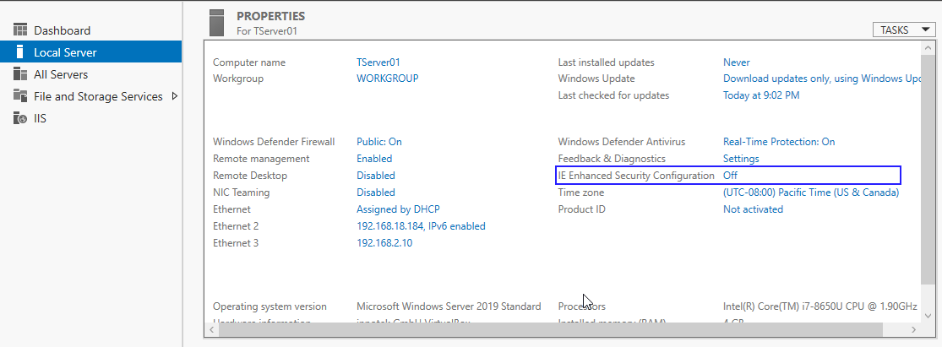

1. Setup SQL Server and features

1. Install SQL Server
2. Select necessary/default features to the SQL server

## Additional Software

Following Installation is required on new SQL server:

* **GP Installation 2013 to include the Dexterity Shared component (Optional)**
* **eConnect Installation 2013**
* **Bitvise SSH Client**
* **CuteFTP 8 Professional (Optional)**
* **GNUPG Privacy guard for encryption**
* **WinSCP**
* **eConnect Installation**

**Step 1** Starts with the eConnect installation on SQL server

* Select “accept” and click “Next”

* Click “Next” to the path where eConnect is installing

* Give the Domain as Server name where you are installing the eConnect. The user can be a local/windows account to run the eConnect services.

**Step 2** After completing the installation deploy the **econnectposting.exe** on SQL server c:\ drive root.